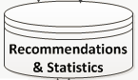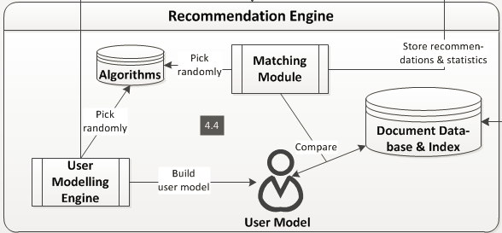

**Web Services**

Process and Store

User Information

Retrieve

Historic activity

**User**

**Management**

Track & Manage workouts, peers, challenges, peer activity, share activity/workouts

**Graphs**

Store/Persist user

Workout activity

Trigger

Recommendation

Deliver

Recommendation

Request

On-Going Marathon Events

Store Latest

Events

Retrieve Latest

Recommendations

Manage

Peers

Manage

Profile

Receive

Notification

Request to Track a Workout

**Client**

**(iOS/iPhone)**

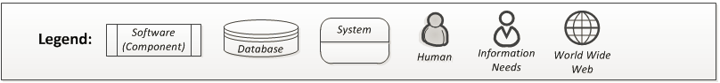

***GPS***